Dear Family and Friends,

Greetings! I pray that this letter finds you and your family well. I am writing to you about an exciting opportunity that the Lord has provided me. A group from my church is planning to attend a short term mission trip to the Dominican Republic.

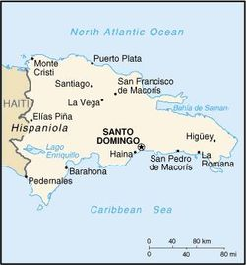
On January 18th, 2014, I will be departing to the town of Hato Mayor, Dominican Republic for a week. This country, along with its neighbor Haiti, is one of the poorest countries in the Caribbean. Their people lack many physical and spiritual needs. The trip is targeted to address both. Such will entail:
I'm going there!
 Hosing project (i.e. village reconstruction)
 Children programs
 Eyeglass and optical support
 Humanitarian relief
 Dental services and others

I'm moreover excited about the fact this trip will not only help others, but it will help me draw close to the Lord. Meeting God in Missions (MGM), which is the organization coordinating this trip, has a specific charter to help the Body of Christ experience God through helping others in this type of venture.

The trip is being funded entirely through donations and by those going on the mission trip. Fundraisers are being held by those going on the trip and the church. Every penny collected will be used towards this endeavor.

This is a great opportunity to serve and to minister, and I ask you to join me in ministry. I am seeking your support and prayers. If you are able to assist, I would ask that you forward any donation (tax-deductible) to me with the check or money order payable to "Grace Alliance Church" annotated with "2014 MGM Mission Trip". An accounting of all funds will be available, should you desire to see it, upon our return from the Dominican Republic.

I thank you in advance for your prayers and financial support. May God bless you richly!

His therefore Yours,

P.S.
For more information on the trip visit our church's website (http://www.gracealliance.org) or MGM's (http://www.meetinggodinmissions.com)
